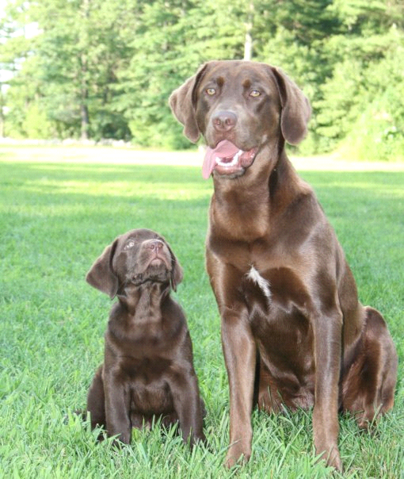Puppy Questionnaire
Highland Farm Labradors
87 Spruce Street
Middleboro MA 02346

The following questions are being asked of you so that the right placement of each puppy is made by bringing the various requirements of both the puppy and his new owner(s) into perspective, BEFORE a choice is made. I hope you will agree that the animal’s welfare/your situation must be an important consideration in considering a placement so that both of you can live in harmony for a long, long time. Please answer the following questions as completely as you can, and return this form when you have finished, signed and dated by the individual to whom the puppy will be registered (new owner).
Because Highland Farm Labradors has everyone's interest in mind the following questionnaire must be completed in full and returned to us prior to purchase of one of our puppies. Thanks, and we look forward to uniting you with your new canine family member!!!
Name

Address

Phone (home/work/cell)

Name of litter (sire and dam) of litter

Color_________Gender_________

Referred by: _____________________

Did you find Highland Farm Labrador on search engine or website? ________
Key word/words you used in your Google search??______________
(this helps us in making sure we are finding the RIGHT clients for our puppies!!)
What reference material have you read?

How familiar are you with this breed?

Type of dwelling (circle one) house condo apartment mobile home

Name, address and phone number of your veterinarian:

1. Who will be the primary care giver?

2. Where will the puppy be kept during the night?

3. Where will the puppy be kept during the day?

4. Is anyone home during the day?

5. How many hours ,on the average will the puppy be alone?

6. Will there be someone available to feed and exercise the puppy during the day?

7. Have you ever owned a dog before?

8. Do you have any other animals?

9. Do you have any children? If yes, what are their ages?

10. How did you hear about this breed?

11. Will the dog be confined and secure when spending time outside? (pen, run, leash, cable/leash)

12. Have you ever house-trained a dog before?

13. How long have you lived at this address?

14. Will you be attending any training classes?

15. How much exercise do you feel is appropriate for your dog?

16. Have you ever returned a pet to the breeder? If so, what were the circumstances?

17. Have you ever given a pet away? If so, what were the circumstances?

18. Have you ever taken a pet to a pound or shelter? If so, what were the circumstances?

19. Are you interested in competition in performance events such as obedience, agility, hunting, conformation?
20. Do you intend to breed the dog?
21. Do you understand the difference between a limited registration and a full registration? I have indicated that I want a (check one) Full____ ( I intend to breed this dog, or keep my options open to breed this dog) Limited______ ( I do not intend to breed this dog, although this dog will STILL be registered) registration when reserving my pup.

22. Do you intend to keep the puppy on the food it is currently eating (Lifes Abundance) that the breeder recommends?

Read and sign the following and return to breeder (Highland Farm Labradors 87 Spruce Street Middleboro MA 02346) before placing deposit on a puppy (please do not just “scan” our information, please read it)

Conditions of Sale

All dogs are sold, with a veterinarian’s health certificate. Within fourteen (14) days of sale, the purchaser of the dog may have the animal examined by a licensed veterinarian of his or her own choosing, and unless said examination indicates the animal to be free from disease, the purchaser shall, at his or her own option, be entitled return the puppy for a full refund of the purchase price of said animal. In order to obtain a full refund the purchaser must present his or her veterinarian’s certificate and proof of sale to the seller within two (2) business days of the examination.

If the purchaser ever decides to find a new home for the puppy the seller will have first option to get the puppy back.

THE SELLER DOES NOT PAY VETERINARIAN BILLS.
They are the purchaser’s responsibility. The seller assumes no responsibility for the puppy after leaving the premises: medical expenses, mortality, landlord’s disapproval, allergy to animals, disagreement of family, or for any reason. It is within the seller’s discretion, as a courtesy, to accept the return of a health puppy. In order to fulfil any guarantee with this puppy the purchaser must ensure this puppy was being fed sugested diet (Lifes Abundance) and properly cared for. If any serious health conditions should occur within the first two years of the puppies life, the seller will refund ½ of the sale price of the puppy after receiving a letter from a veterinarian confirming that the issue is hereditary. If the purchaser perfers to return the puppy because of health issue and have it replaced with a new puppy upon availability.

Reservation is not considered “final” until your return this form with your signature below. Thanks!
Signature of new puppy owner ___________________________________________

Date__________

